Java SE Project

Hospital Management System Application

***Database Design Documentation***

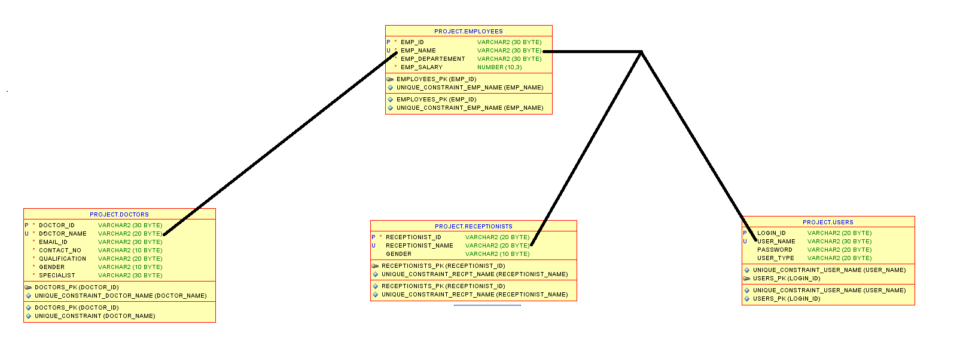

1. ***Design Employee Table :***

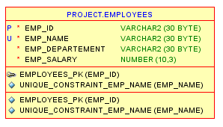

**Command :**

**CREATE TABLE EMPLOYEES (**

**"EMP_ID" VARCHAR2(30),**

**"EMP_NAME" VARCHAR2(30) NOT NULL ,**

**"EMP_DEPARTMENT" VARCHAR2(30) NOT NULL ,**

**"EMP_SALARY" NUMBER(10,3) NOT NULL ,**

**CONSTRAINT "EMPLOYEES_PK" PRIMARY KEY ("EMP_ID")**

**);**

1. ***Design Doctor Table :***

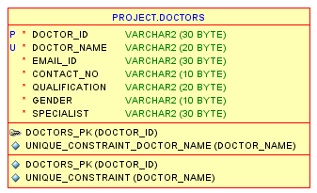

**Command :**

**CREATE TABLE DOCTORS (**

**"DOCTOR_ID" VARCHAR2(30) NOT NULL ,**

**"DOCTOR_NAME" VARCHAR2(20) NOT NULL ,**

**"EMAIL_ID" VARCHAR2(30) NOT NULL ,**

**"CONTACT_NO" VARCHAR2(10) NOT NULL ,**

**"QUALIFICATION" VARCHAR2(20) NOT NULL ,**

**"GENDER" VARCHAR2(10) NOT NULL ,**

**"SPECIALIST" VARCHAR2(30) NOT NULL ,**

**CONSTRAINT "DOCTORS_PK" PRIMARY KEY ("DOCTOR_ID")**

**);**

1. ***Design Receptionist Table ;***

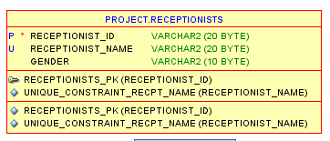

**Command :**

**CREATE TABLE RECEPTIONISTS (**

**"RECEPTIONIST_ID" VARCHAR2(20) NOT NULL ,**

**"RECEPTIONIST_NAME" VARCHAR2(20),**

**"GENDER" VARCHAR2(10),**

**CONSTRAINT "RECEPTIONISTS_PK" PRIMARY KEY ("RECEPTIONIST_ID")**

**);**

1. ***Design Patients Table :***

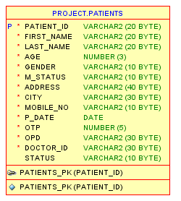

**Command :**

**CREATE TABLE PATIENTS (**

**"PATIENT_ID" VARCHAR2(20),**

**"FIRST_NAME" VARCHAR2(20) NOT NULL ,**

**"LAST_NAME" VARCHAR2(20) NOT NULL ,**

**"AGE" NUMBER(3,0) NOT NULL ,**

**"GENDER" VARCHAR2(10) NOT NULL ,**

**"M_STATUS" VARCHAR2(10) NOT NULL ,**

**"ADDRESS" VARCHAR2(40) NOT NULL ,**

**"CITY" VARCHAR2(30) NOT NULL ,**

**"MOBILE_NO" VARCHAR2(10) NOT NULL ,**

**"P_DATE" DATE NOT NULL ,**

**"OTP" NUMBER(5,0) NOT NULL ,**

**"OPD" VARCHAR2(30) NOT NULL ,**

**"DOCTOR_ID" VARCHAR2(30) NOT NULL ,**

**"STATUS" VARCHAR2(10),**

**CONSTRAINT "PATIENTS_PK" PRIMARY KEY ("PATIENT_ID")**

**);**

1. ***Design Users Table:***

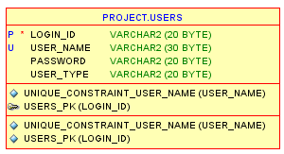

**Command :**

**CREATE TABLE USERS (**

**"LOGIN_ID" VARCHAR2(20),**

**"USER_NAME" VARCHAR2(30),**

**"PASSWORD" VARCHAR2(20),**

**"USER_TYPE" VARCHAR2(20),**

**CONSTRAINT "USERS_PK" PRIMARY KEY ("LOGIN_ID")**

**);**

1. ***Design Appointments Table :***

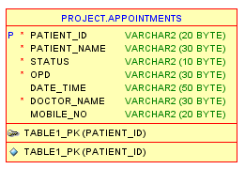

**Command :**

**CREATE TABLE APPOINTMENTS (**

**"PATIENT_ID" VARCHAR2(20) NOT NULL ,**

**"PATIENT_NAME" VARCHAR2(30) NOT NULL ,**

**"STATUS" VARCHAR2(10) NOT NULL ,**

**"OPD" VARCHAR2(30) NOT NULL ,**

**"DATE_TIME" VARCHAR2(50),**

**"DOCTOR_NAME" VARCHAR2(30) NOT NULL ,**

**"MOBILE_NO" VARCHAR2(20),**

**CONSTRAINT "TABLE1_PK" PRIMARY KEY ("PATIENT_ID")**

**);**

**Thank You**